|  |
| --- |
| Formsteel |
| Structural Report |
| PS1 – Structural calculation and design report |

|  |
| --- |
| Formsteel  4-25-2019 |



Contents

1. Geometry 2

1.1. Basic geometry 2

1.2. Structural model in 3D environment 2

2. Material properties 3

3. Cross-sections 4

4. Member types 6

5. Load 7

5.1. Basic Parameters 7

5.2. Dead Load 7

5.3. Service load 7

5.4. Live / Imposed Load 7

5.5. Snow Load 7

5.6. Wind Load 7

5.7. Seismic Load 8

6. Load Cases 10

7. Load Combinations 11

8. Member design 12

8.1. Member type: Main Column 12

8.1.1. Member internal forces 12

8.1.2. Frame internal forces 13

8.1.3. Member design details - ULS 14

8.1.4. Member deflections 14

8.1.5. Member design details - SLS 14

9. Joint Design 15

9.1. Member type: Main Column 15

10. Footing Design 17

# Geometry

## Basic geometry

Width B = [GableWidth] m

Length L = [Length] m

Height H1 = [WallHeight] m

~~Height H~~~~2~~ ~~= 4.48 m~~~~2~~

Roof Pitch α = [RoofPitch_deg] deg

Girt spacing Bg = [GirtDistance] m

Purlin spacing Bp = [PurlinDistance] m

Wind post spacing Bwp = [ColumnDistance] m

Rafter length 9.423 m

Toto by som asi dal do tabulky, aby to bolo pekne naformatovane

Pismenka zakladneho fontu by mali byt co najmensie a citatelne “10”???

Pointa je vsetko nahustit tak aby sme mali co najmenej stran a co najhutnejsie data.

## Structural model in 3D environment

Orezat biele okraje obrazka aby bol co najvacsi. Este sa musime trosku pohrat s farbami aby to na bielom pozadi vyzeralo lepsie. Asi budeme potrebovat 2 sady farieb pre 3D grafiku a ine pre export.

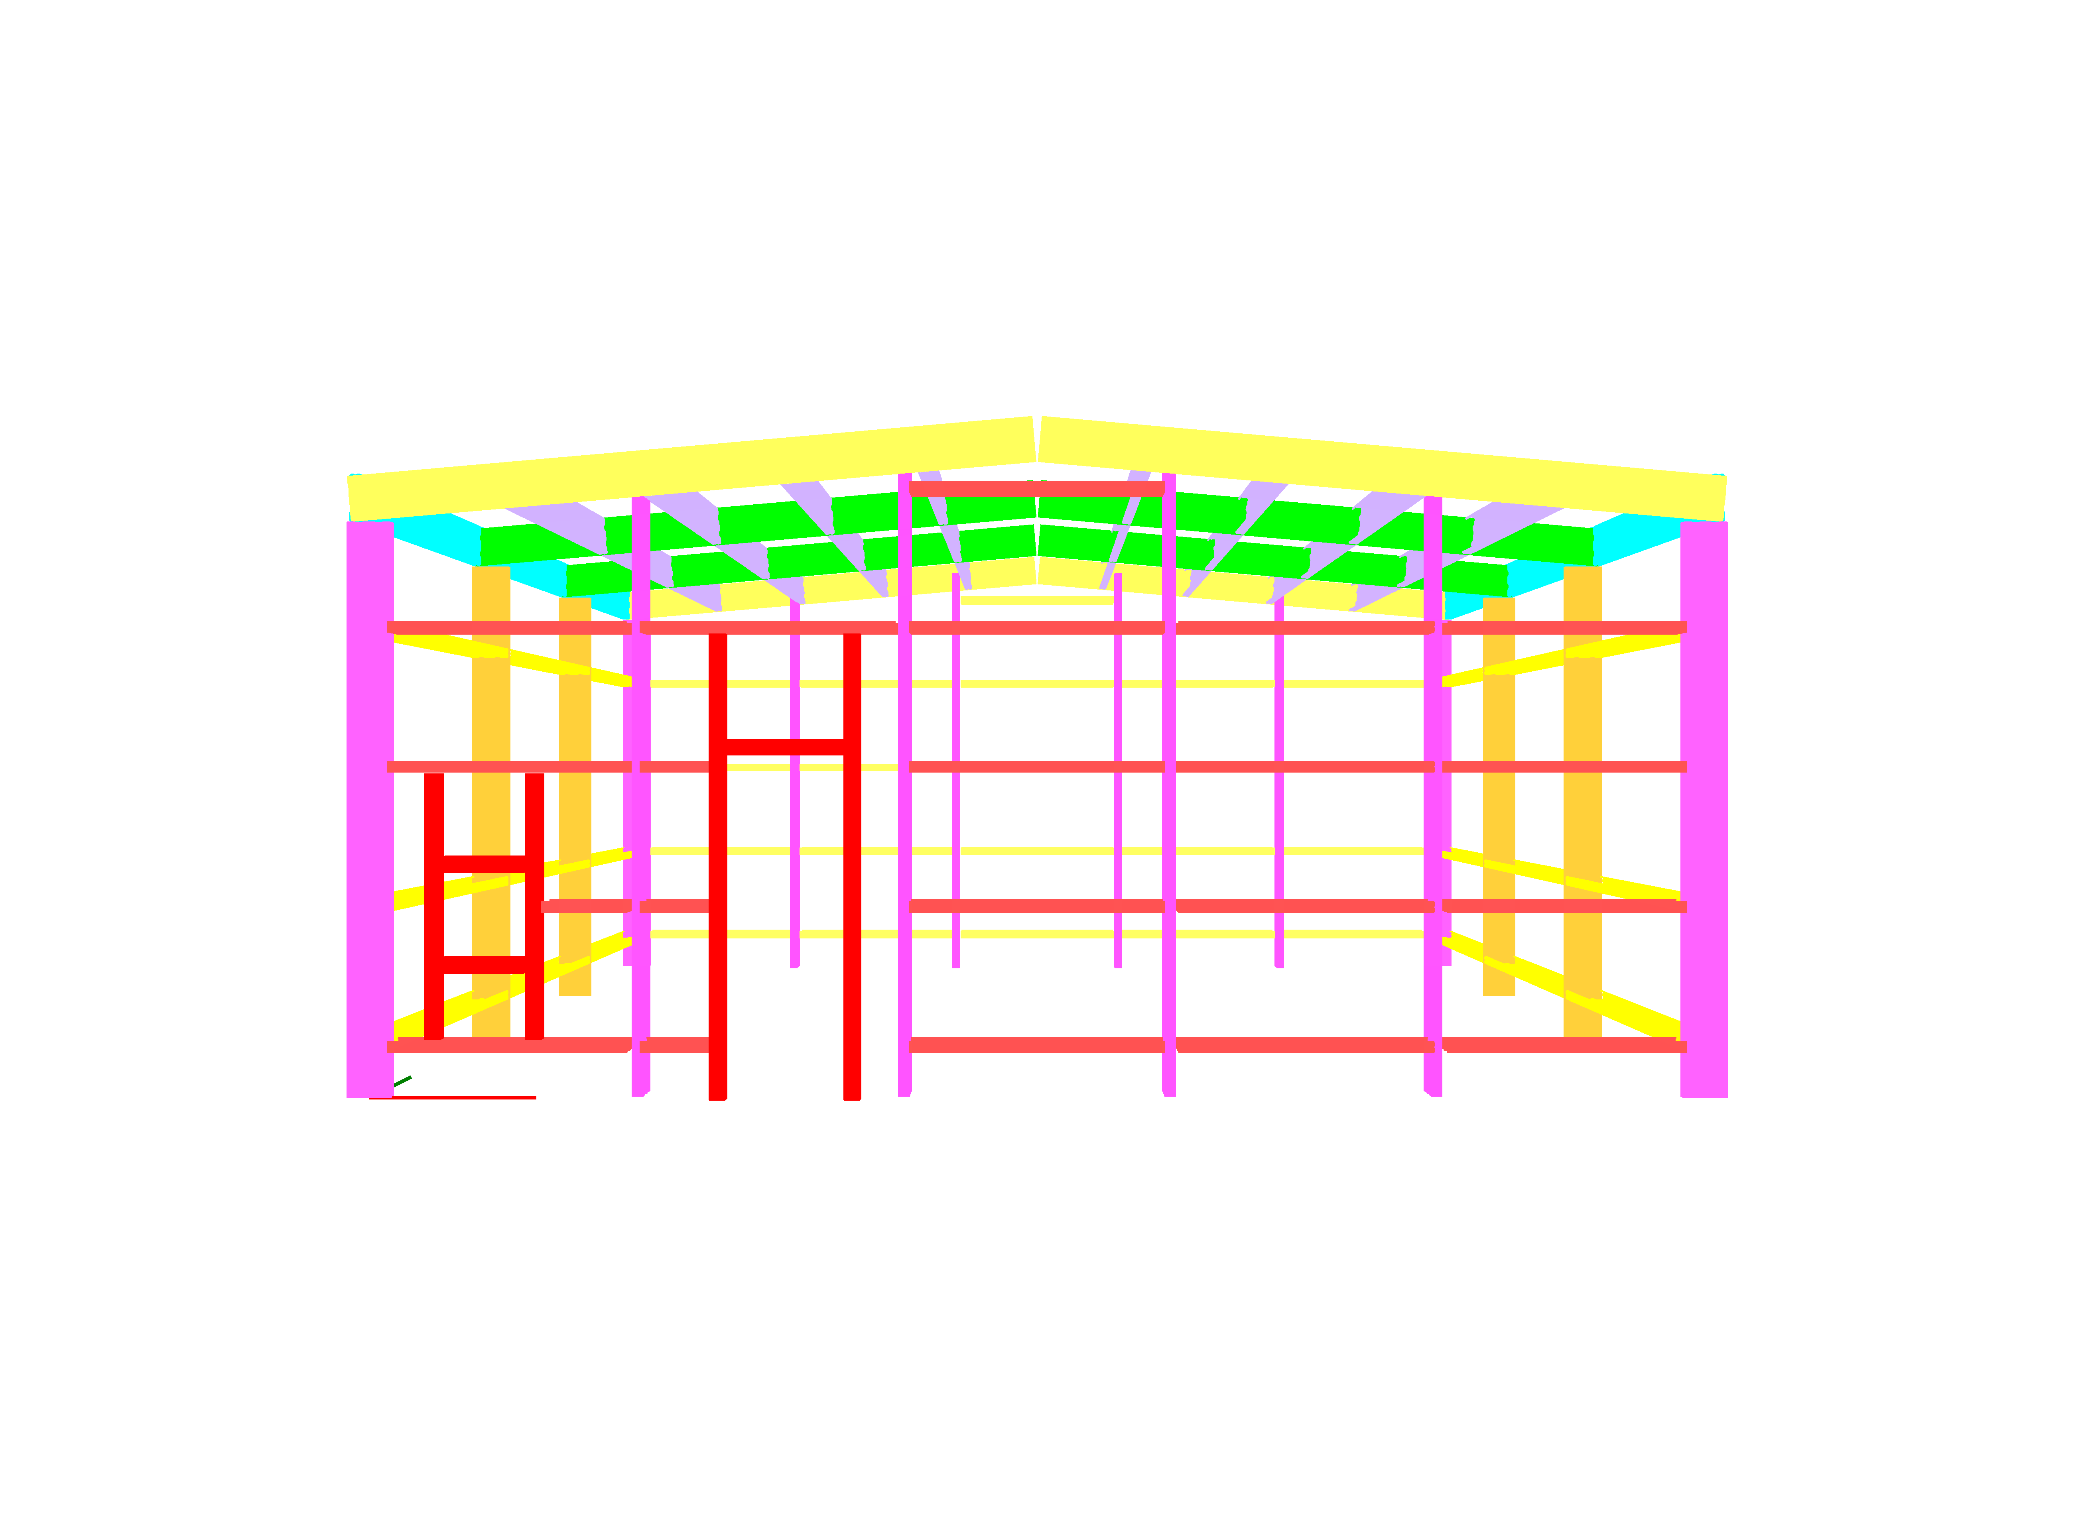

# Material properties

V UC_ComponentList, Datagrid_Components zistit kolko roznych materialov je zadanych componentam, asi to bude na 99% G550 pre vsetky komponenty. Pre kazdy z tychto materialov zobrazit tabulku obsahujucu udaje v datagride Datagrid_Materials

V kode by bolo dobre mat moznost nastavit ktore riadky tabulky sa exportuju, nepotrebujeme vsetky, defaultne vypnut tie ktore su prazdne.

Ak by to slo tak by mohli byt tabulky aj vedla seba. Usetrime riadky

Material grade: G550‡

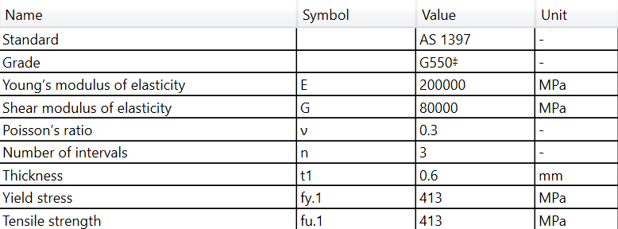

Material grade: 450

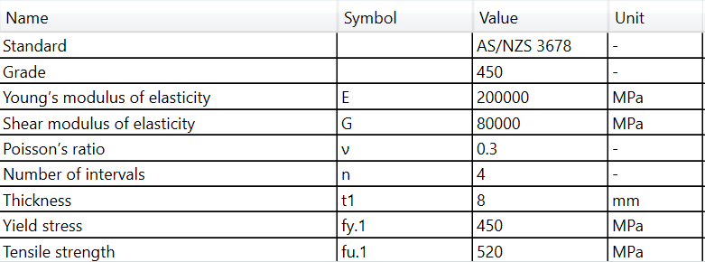

# Cross-sections

V UC_ComponentList, Datagrid_Components zistit kolko roznych prierezov je zadanych componentam. Pre kazdy z tychto prierezov podla nazvu prierezu zobrazit tabulku obsahujucu udaje v datagride Datagrid_ComponentDetails.

Pred tabulku alebo vedla tabulky zobrazit obrazok prierezu (obrazky pripravim). Obrazok prierezu by mohol byt vedla tabulky. Usetrili by sa riadky.

V kode by bolo dobre mat moznost nastavit ktore riadky tabulky sa exportuju, nepotrebujeme vsetky. Defaultne vypnut tie, ktore su prazdne.

Ak bude na stranke malo miesta, tak skocit na dalsiu, na jednu stranku by sa mohli zmestit 2 prierezy

Cross-section name: 63020

|  |  |
| --- | --- |
|  |  |

Cross-section name: 270115

|  |  |
| --- | --- |
|  |  |

# Member types

Zobrazit tabulku UC_ComponentList, Datagrid_Components bez checkboxov.

Mozno by bolo dobre pridat do toho datagridu este jeden stlpec “Color”. Farbu jednotlivych komponent by sme potom mohli cez GUI nastavovat. Zaroven bude mozne rychlo identifikovat co je co podla farieb na 3D obrazku. Niektore programy maju farbu priradenu typom objektov ako je material, cross-section, component type atd a da sa v 3D medzi tymi farbami prepinat takze je lahko identifikovatelne co je aky prierez, aky material a podobne (vid obrazok pod tabulkou)

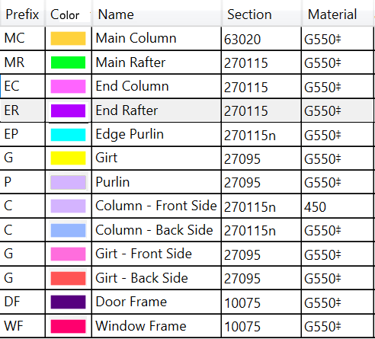

Ukazka zo SPACE GASS – farby v 3D a legenda vpravo

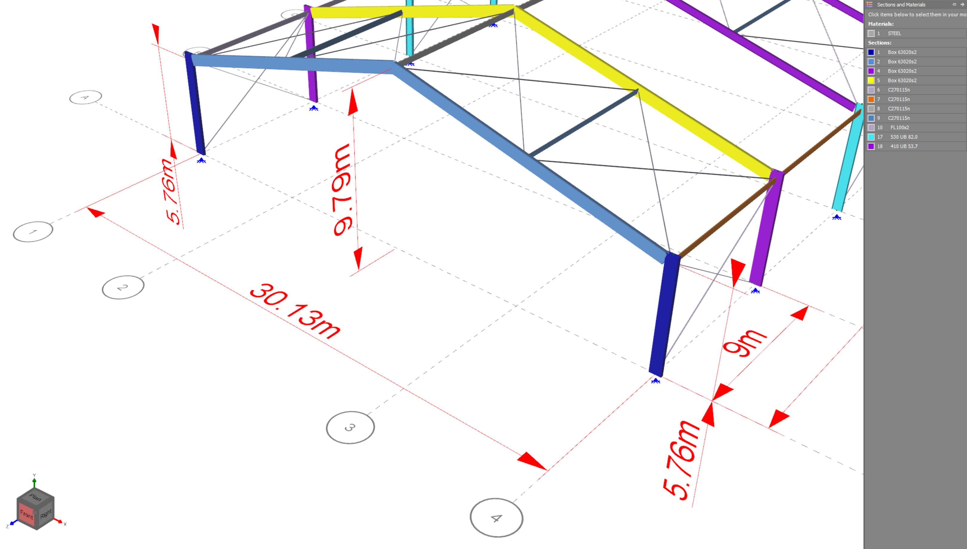

Ukazka RSTAB – 3D grafika s legendou a obrazok v protokole

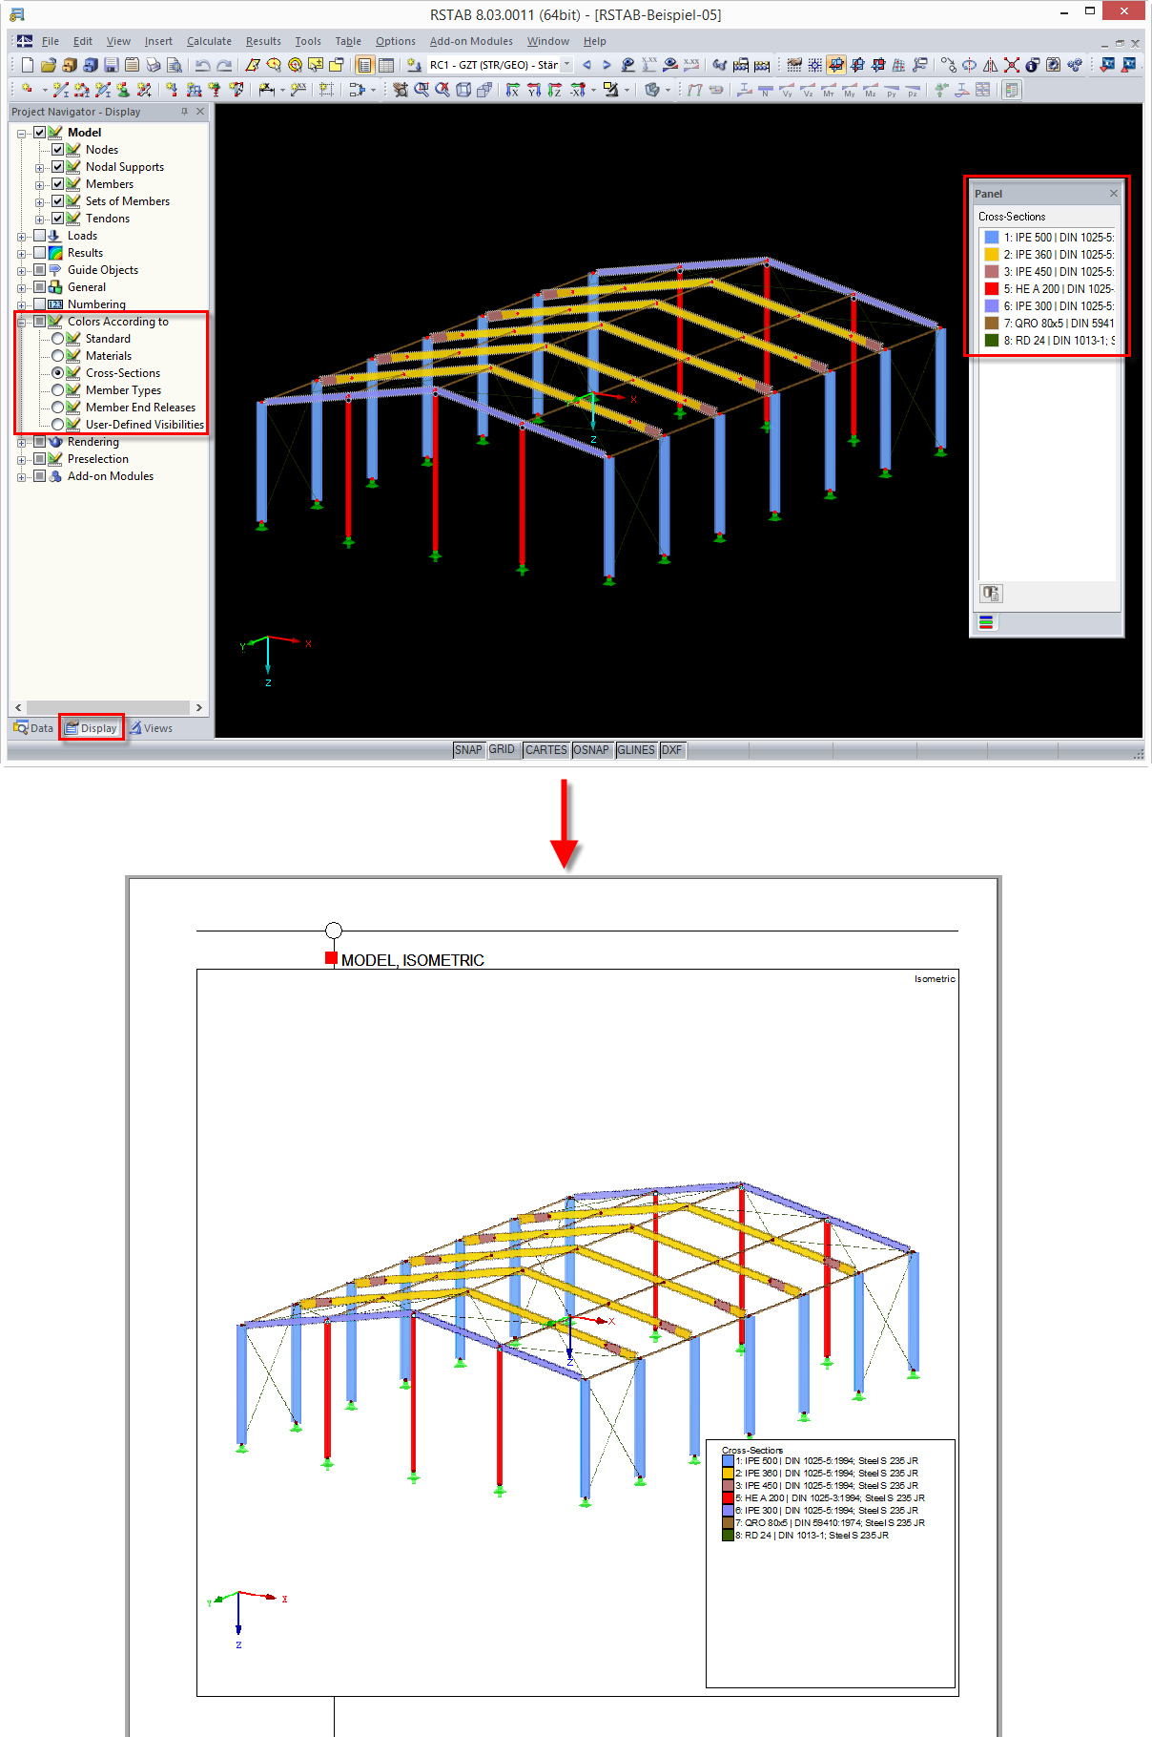

# Load

## Basic Parameters

Location: [Location]

Design life: [DesignLife_Value] years

Importance level: [ImportanceClass]

Annual probability of exceedance SLS: [AnnualProbabilitySLS]

Return period SLS: RSLS = [R_SLS] years

Site elevation E = [SiteElevation] m

## Dead Load

TODO – potrebujeme spristupnit premenne v objekte cez properties

Wall cladding load g c.w = [CCalcul_1170_1.DeadLoad_Wall] kN/m2

Roof cladding load g c.r = [CCalcul_1170_1.DeadLoad_Roof] kN/m2

Additional wall load g a.w = [AdditionalDeadActionWall] kN/m2

Additional roof load g a.r = [AdditionalDeadActionRoof] kN/m2

Total wall load g t.w = [CCalcul_1170_1.DeadLoadTotal_Wall] kN/m2

Total roof load g t.r = [CCalcul_1170_1.DeadLoadTotal_Roof] kN/m2

## Service load

Todo – if necessary

## Live / Imposed Load

Roof live load q l.r = [ImposedActionRoof] kN/m2

## Snow Load

TODO – potrebujeme spristupnit premenne v objekte cez properties

Annual probability of exceedance ULS: [AnnualProbabilityULS_Snow]

Return period RULS.S = [R_ULS_Snow] years

Snow elevation region: [CCalcul_1170_3.eSnowElevationRegion]

Ground snow load sg.ULS = [CCalcul_1170_3.s_g_ULS] kN/m2

Ground snow load sg.SLS = [CCalcul_1170_3.s_g_SLS] kN/m2

Roof exposure category [ExposureCategory]

Exposure factor Ce = [CCalcul_1170_3.C_e]

Factor μ1 = [CCalcul_1170_3.Nu1_Alpha1]

Factor μ2 = [CCalcul_1170_3.Nu2_Alpha1]

Roof snow load sULS = [CCalcul_1170_3.s_ULS] kN/m2

Roof snow load sSLS = [CCalcul_1170_3.s_SLS] kN/m2

## Wind Load

TODO – potrebujeme spristupnit premenne v objekte cez properties

Annual probability of exceedance ULS: [AnnualProbabilityULS_Wind]

Return period RULS.W = [R_ULS_Wind] years

Wind region [EWindRegion]

Terrain category [TerrainCategory]

Reference height z = [CCalcul_1170_2.z] m

Average structure height h = [CCalcul_1170_2.h] m

Regional 3s gust wind speed VR.ULS = [CCalcul_1170_2.V_R_ULS] m/s

Regional 3s gust wind speed VR.SLS = [CCalcul_1170_2.V_R_SLS] m/s

Terrain/height multiplier Mz.cat = [CCalcul_1170_2.M_z_cat]

Shielding multiplier Ms = [CCalcul_1170_2.M_s]

Topographic multiplier Mt = [CCalcul_1170_2.M_t]

Hodnoty sa daju pocitat rozne pre smery vetra N,W,E,S. Zatial budeme zobrazovat len hodnoty s indexom [0]

Wind direction multiplier Md = [CCalcul_1170_2.fM_D_array_values_9[0]]

Site wind speed Vsit,β.ULS = [CCalcul_1170_2.V_sit_ULS_Theta_9[0]] m/s

Site wind speed Vsit,β.SLS = [CCalcul_1170_2.V_sit_SLS_Theta_9[0]] m/s

Design wind speed Vdes,θ.ULS = [CCalcul_1170_2.V_des_ULS_Theta_4[0]] m/s

Design wind speed Vdes,θ.SLS = [CCalcul_1170_2.V_des_SLS_Theta_4[0]] m/s

Density of air ρair = [CCalcul_1170_2.Rho_air] kg/m3

Dynamic response factor Cdyn = [CCalcul_1170_2.C_dyn]

Basic wind pressure pb.ULS = [CCalcul_1170_2.p_basic_ULS_Theta_4[0]] kN/m2

Basic wind pressure pb.SLS = [CCalcul_1170_2.p_basic_SLS_Theta_4[0]] kN/m2

## Seismic Load

Equivalent static method parameters

Annual probability of exceedance ULS: [AnnualProbabilityULS_EQ]

Return period RULS.EQ = [R_ULS_EQ]

Site subsoil class [ESiteSubSoilClass]

Fault distance Dmin = [FaultDistanceDmin] km

Fault distance Dmax = [FaultDistanceDmax] km

Zone factor Z = [ZoneFactorZ]

Natural period along X-direction Tx = [PeriodAlongYDirectionTx] s

Natural period along Y-direction Ty = [PeriodAlongYDirectionTy] s

Spectral shape factor Ch(Tx) = [SpectralShapeFactorChTx]

Spectral shape factor Ch(Ty) = [SpectralShapeFactorChTy]

ULS

TODO – potrebujeme spristupnit premenne v objekte cez properties

Structural ductility factor ULS μ = [CCalcul_1170_5.Nu_ULS]

Structural performance factor ULS Sp = [CCalcul_1170_5.S_p_ULS_strength]

Near-fault factor N(Tx,D) =[CCalcul_1170_5.N_TxD_ULS]

Elastic site hazard spectrum C(Tx) = [CCalcul_1170_5.C_Tx_ULS]

Factor kμ(Tx) = [CCalcul_1170_5.k_Nu_Tx_ULS]

Horizontal design action coefficient Cd (Tx) = [CCalcul_1170_5.C_d_T1x_ULS_strength]

Contributing weight Gtot.x = [CCalcul_1170_5.G_tot_x] kN

Horizontal static force Vx = [CCalcul_1170_5.V_x_ULS_strength] kN

Near-fault factor N(Ty,D) =[CCalcul_1170_5.N_TyD_ULS]

Elastic site hazard spectrum C(Ty) = [CCalcul_1170_5.C_Ty_ULS]

Factor kμ(Ty) = [CCalcul_1170_5.k_Nu_Ty_ULS]

Horizontal design action coefficient Cd (Ty) = [CCalcul_1170_5.C_d_T1y_ULS_strength]

Contributing weight Gtot.y = [CCalcul_1170_5.G_tot_y] kN

Horizontal static force Vx = [CCalcul_1170_5.V_y_ULS_strength] kN

SLS - TODO

~~Structural ductility factor SLS μ = [CCalcul_1170_5.Nu_SLS]~~

~~Structural performance factor SLS S~~~~p~~ ~~= [CCalcul_1170_5.S_p_SLS]~~

# Load Cases

Vlozit tabulku z UC_LoadCasesList - datagrid Datagrid_LoadCases.

Ak je tabulka dlhsia nez jedna strana potrebujeme ju rozdelit a na kazdu stranku zobrazit hlavicku tabulky.

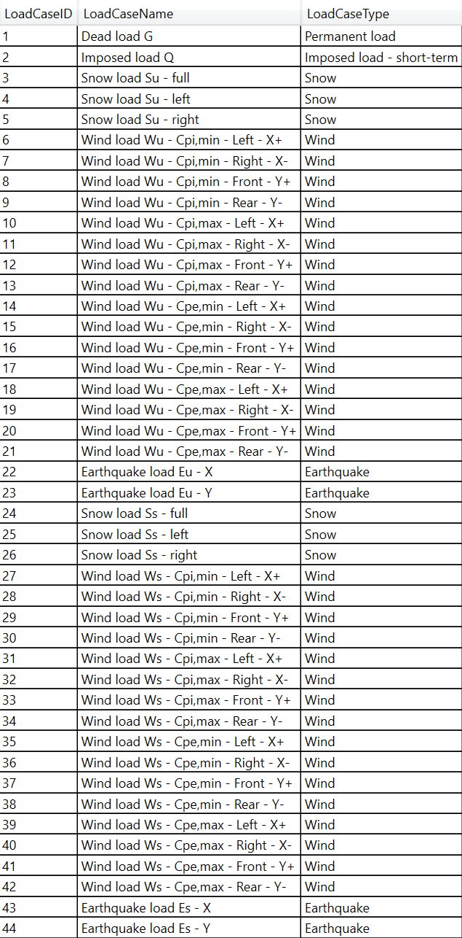

# Load Combinations

Vlozit tabulku z UC_LoadCombinationsList - datagrid Datagrid_LoadCombinations.

Ak je tabulka dlhsia nez jedna strana potrebujeme ju rozdelit a na kazdu stranku zobrazit hlavicku tabulky.

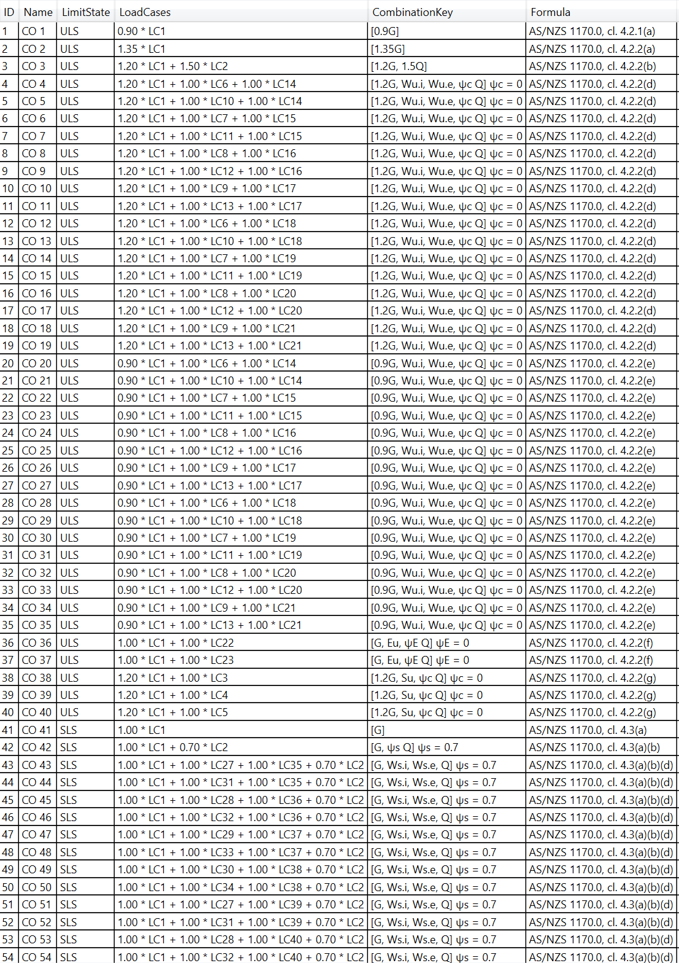

# Member design

Pre kazdy typ komponenty z Tab Members ktora ma zaskrtnuty Design vlozit tabulku vysledkov z Member Design, vlozit obrazky s priebehmi vnutornych sil (internal forces) pre danu

komponentu a kombinaciu pri ktorej vzniklo rozhodujuce design ratio.

Pre pruty ramov zobrazit aj priebeh vnutornych sil na rame.

Kapitola 8.1 by sa mala generovat v cycle (8.1, 8.2. 8.3 … 8. N) pre vsetky componenty 1 - N, ktore maju zaskrtnute Design

## Member type: Main Column

Governing member ID: xxx

Governing load combination ID: xxx

### Member internal forces

Obrazky y UC_InternalForces, jeden canvas – jeden obrazok. Canvas, ktore maju vsetky values 0 neexportovat.

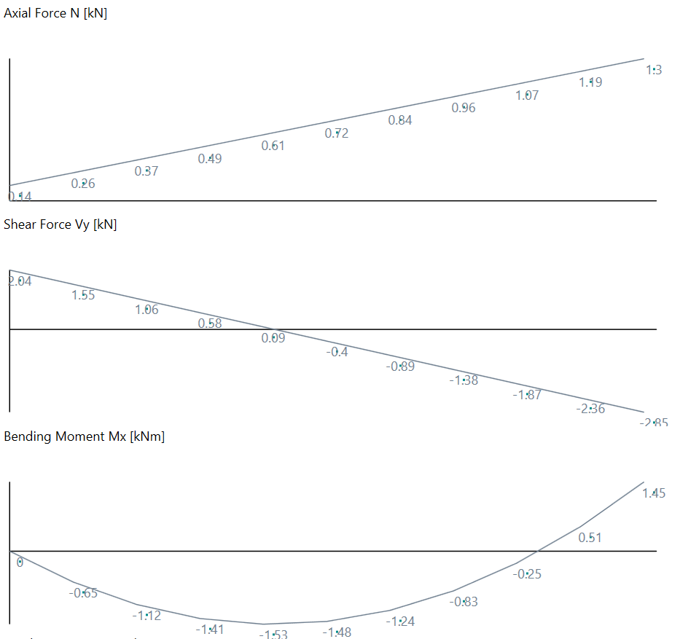

Ak je prut typu EC, ER, MC alebo MR zobrazit aj vnutorne sily na rame, do ktoreho posudzovany prut patri – dialog FrameInternalForces_2D. Nulove priebehy vynechat.

### Frame internal forces

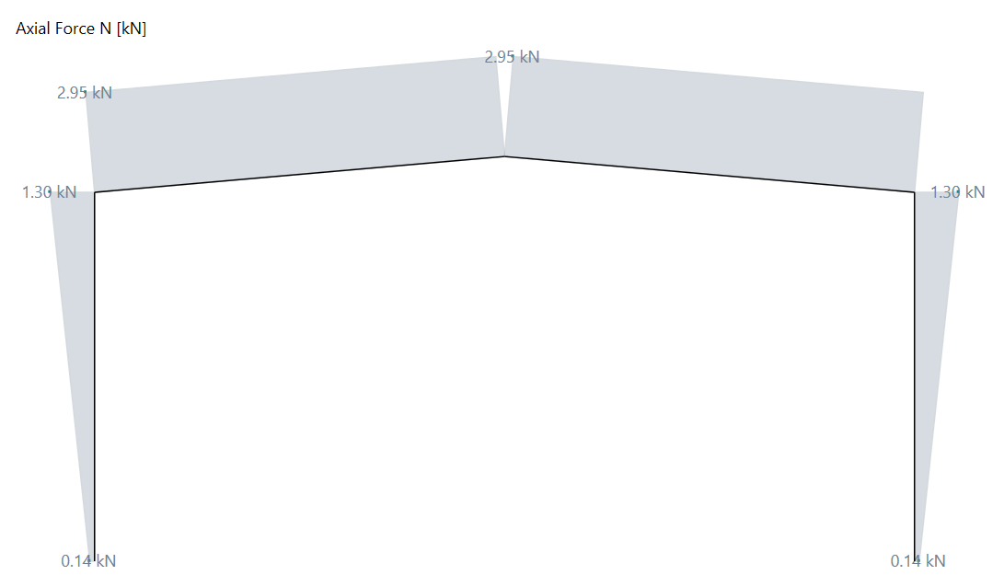

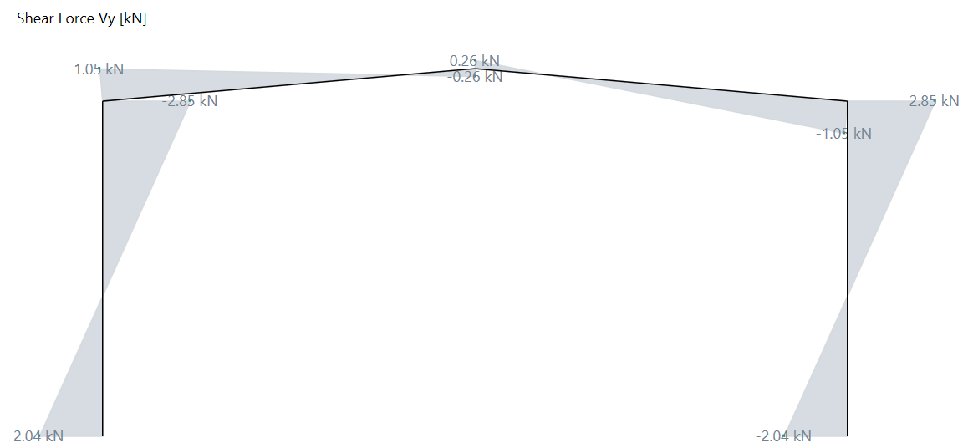

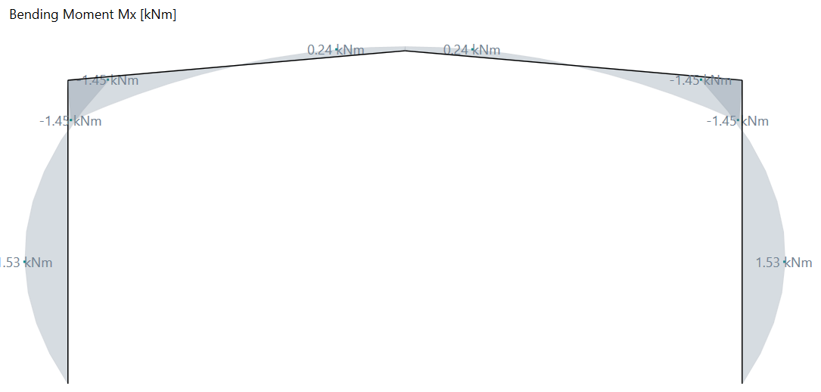

### Member design details - ULS

Zobrazit detaily z UC_MemberDesign

Zobrazit detaily pre rozhodujucu kombinaciu zo skupiny ULS

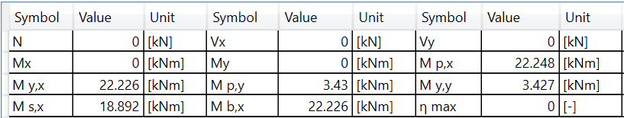

### Member deflections

TODO Obrazky z UC_Deflection, jeden canvas – jeden obrazok. Canvas, ktore maju vsetky values 0 neexportovat.

Toto este potrebujeme dopracovat.

### Member design details - SLS

Zobrazit detaily pre rozhodujucu kombinaciu zo skupiny SLS



# Joint Design

Podobne vlozit pre kazdu komponentu tabulky vysledkov spojov z Joint Design pre rozhodujuce kombinacie vnutornych sil (max design ratio).

## Member type: Main Column

Zobrazit pre kazdy typ combponenty so zaskrtnutym Design detaily posudku spojov z UC_JointDesign

TODO - Potrebovali by sme tu vlozit obrazok spoja na zaciatku a na konci pruta v 3D alebo 2D.

Pre 2D by sme mohli pouzit to canvas zo System Component Viewer

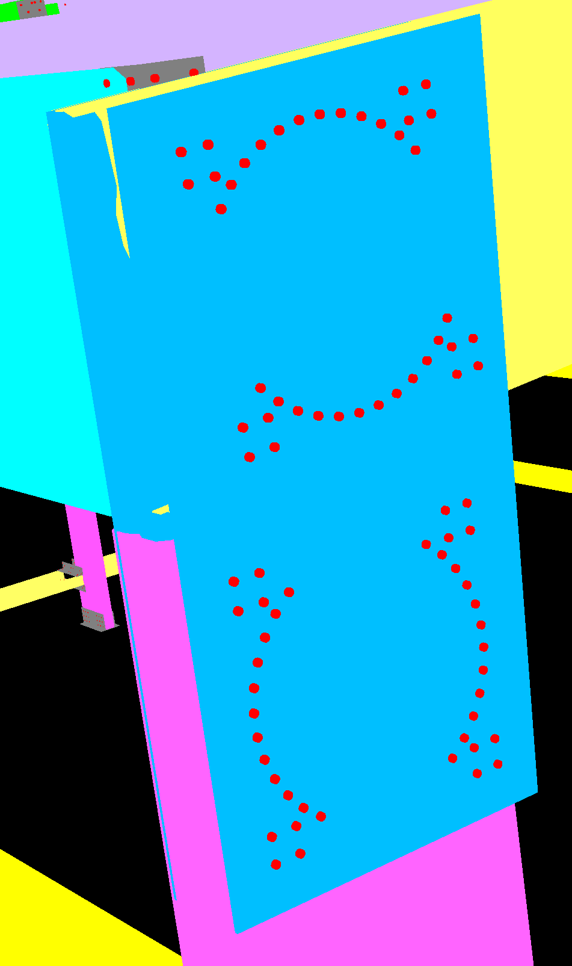 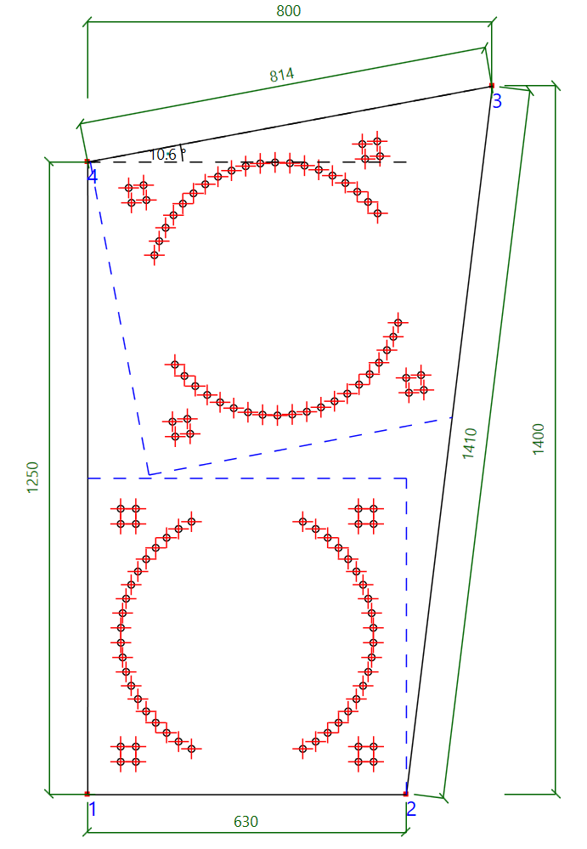

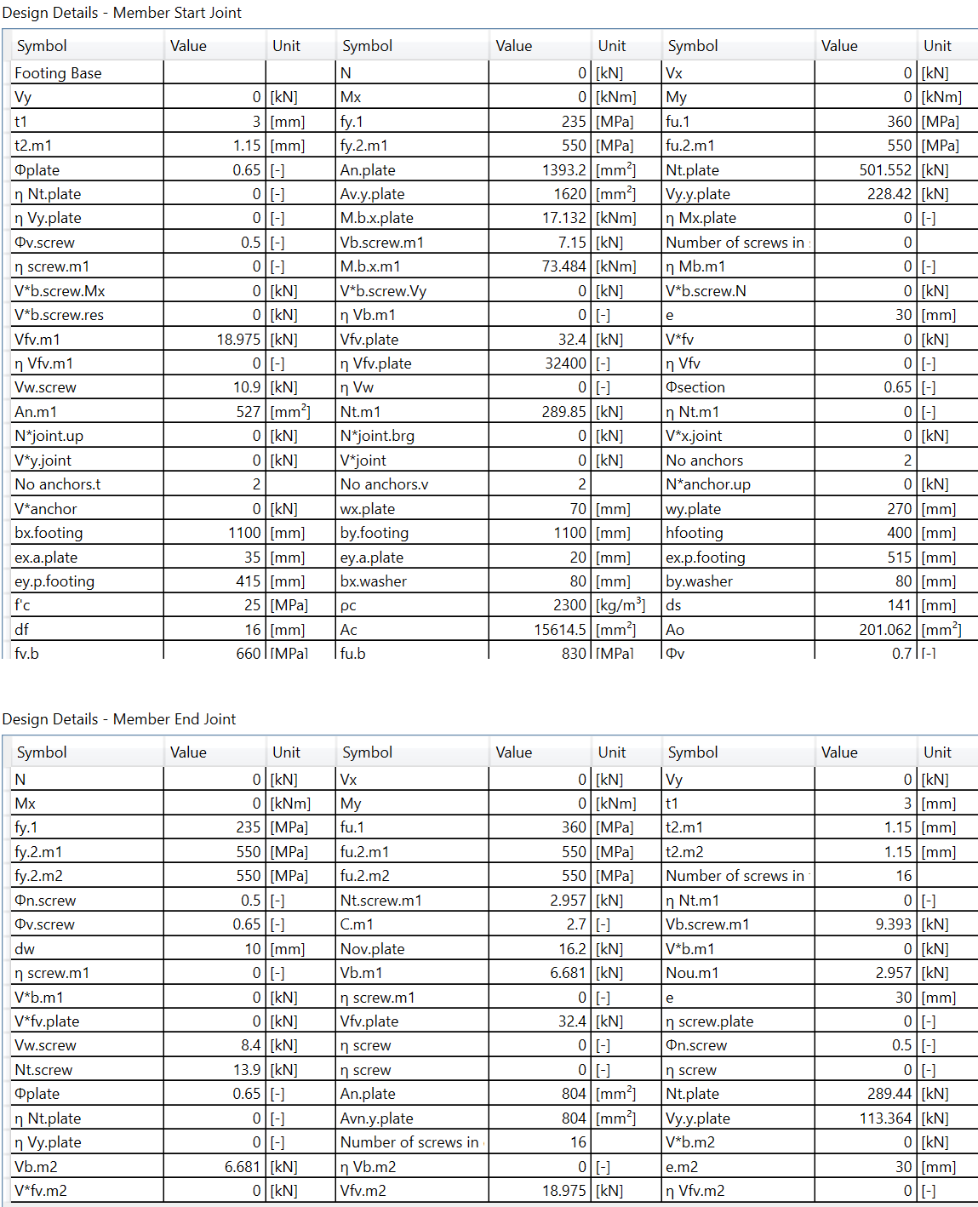

# Footing Design

TODO (oddelit vysledky od joint design)

**Po ukonceni generovania report potrebujeme updatovat Obsah (update field Ctrl + A and F9)**